TRIBAL PERCEPTION SCALE: A SCALE DEVELOPMENT STUDY
AŞİRET ALGISI ÖLÇEĞİ: BİR ÖLÇEK GELİŞTİRME ÇALIŞMASI
Engin KORKMAZ*
Abstract
The purpose of this study is to shed light on how students at Hakkari University see the political and social components of the concept of tribe. Using the information obtained from the group interview and literature review, a five-way Likert survey containing questions about the notion of tribe were administered to Hakkari University students for the 2022–2023 academic year. Using the SPSS tool, Exploratory Factor Analysis (EFA) was performed on 231 survey responses. In addition, a Confirmatory Factor Analysis (CFA) was conducted on the data acquired from 174 participants using the AMOS program. As a result of the analyses, the Tribal Perception Scale (TPS) with 15 items and two sub dimension was developed. The Cronbach Alpha of this scale was discovered to be 0.85 as a result of an examination of its reliability. The social and political perception subdimensions of the scale were found to be 0.88 and 0.76, respectively, and this scale was found to account for 51.671% of the total variance. This result led to the conclusion that TPS is a highly valid and trustworthy instrument for data gathering.
Keywords: Tribe, social belonging, political participation, political sociology, scale development, validity, reliability.
Öz
Bu araştırmanın amacı, aşiret kavramının siyasi ve sosyolojik yönünün Hakkari Üniversitesinde okuyan öğrencilerin algılarındaki yerini ortaya çıkarmaktır. Grup görüşmesi ve alan yazın taraması neticesinde elde edilen verilerle aşiret kavramı ile ilgili sorular hazırlanarak beşli likert anketi haline getirilip 2022-2023 öğretim döneminde Hakkâri Üniversitesinde okuyan öğrencilere çevrimiçi olarak gönderilmiştir. Anket sonucunda elde edilen 231 veriye SPSS programı ile Açımlayıcı Faktör Analizi (AFA) analizi yapılmıştır. Ayrıca 174 kişiden elde edilen veriler, AMOS programı ile Doğrulayıcı Faktör Analizi (DFA) analizine tabi tutulmuştur. Yapılan analizler neticesinde 15 madde ve iki boyuttan oluşan Aşiret Algısı Ölçeği (AAÖ) geliştirilmiştir. Bu ölçeğin güvenirlik analizi sonucunda, ölçeğin Cronbach Alpha katsayısı .85 olarak tespit edilmiştir. Bunun yanında ölçeğin sosyolojik algı alt boyutu .88 ve siyasi algı alt boyutu .76 olarak belirlenmiş ve bu ölçeğin toplam varyansın % 51,671’ni açıkladığı belirlenmiştir. Bu sonuca göre geliştirilen AAÖ’nün geçerliliği ve güvenirliliği yüksek bir veri toplama aracı olduğu tespit edilmiştir.
Anahtar Kelimeler: Aşiret, toplumsal aidiyet, siyasal katılım, siyaset sosyolojisi, ölçek geliştirme, geçerlilik, güvenirlik.

INTRODUCTION
The notion of tribe, possesses a significant historical lineage within the annals of the Middle East and Anatolia. In this regard, it is imperative to establish a clear definition of the concept of tribe, which serves as the focal point of this study. Consequently, it is essential to consult relevant literature and provide comprehensive explanations pertaining to the nature and characteristics of tribes. A tribe can be defined as a social group comprised of individuals who share a common lineage or perceive themselves to be connected in such a manner. The etymology of the term "tribe" can be traced back to its Arabic origin, wherein it denotes a collective of individuals who share a common lineage, either through a factual or mythical progenitor (Bruinessen, 2013, p. 82; Korkmaz, 2018, p. 17; Gökalp, 2011, p. 25-26). A tribe can be understood as a social structure in which individuals co-exist with the intention of fulfilling shared necessities and cultivating a collective sense of identity (Uluç, 2010, p. 39). The tribal structure comprises two fundamental components. One aspect pertains to the communal mode of existence, while the other concerns the notion of a shared progenitor (Aladağ, 1981, p. 147). Given the prevailing nomadic or semi-nomadic nature of tribes, individuals who coexist over an extended period may perceive themselves as belonging to a particular tribal community. Within the Kurdish tribes, a hierarchical structure can be observed, encompassing various levels of social organization. At the lowest level, we find the concept of "mal," which refers to the immediate family unit. Moving beyond this, the next level of social grouping is known as "malbat," which denotes the extended family. Further up the hierarchy, we encounter the notion of lineage, followed by the larger social unit of the tribe. It is worth noting that within the tribe itself, there exists an additional level of organization, referred to as "tribe" (Karadeniz, 2012, p. 18). Within the framework of familial relationships, there exists a categorization known as kurmam (paternal uncle's son), pısmam (paternal uncle's son's son), bınam (relatives up to seven generations), wêris (inheritors), ûcax (household), xungir (close blood relatives), village, tribe, and clan (Korkmaz, 2018, p. 24). Within the context of Kurdish society, it is observed that various smaller tribes come together and establish a confederation of tribes. In the region of Hakkari, two prominent tribal confederations exist, namely Ertuşi and Pinyanişi. Each tribal confederation comprises numerous tribes.
When considering the matter within the framework of relationship forms, it can be argued that the tribal structure in Eastern Anatolia exhibits a relatively higher degree of democratic characteristics compared to certain cities in Southeastern Anatolia, particularly Urfa, Ağrı, and Diyarbakır. The rationale behind this distinction lies in the contrasting socio-economic practices observed among the tribes residing in Eastern Anatolia and those inhabiting South East Anatolia. Specifically, the former exhibit a nomadic or semi-nomadic lifestyle, primarily centered around livestock rearing, whereas the latter adopt a sedentary way of life, primarily reliant on agricultural activities. The nomadic lifestyle of various tribes was brought to a halt and a significant portion of these tribes relocated to urban areas as a consequence of the outbreak of violence during the 1990s (Abdulla, 2010, p. 58-59). When considering the concept of tribes, a prominent aspect that arises is the belief that tribal formations are based on feudal relationships. However, it is inaccurate to assert that all the tribes residing in rural areas and urban centers were exclusively established based on feudal relationships. In the feudal system, the nobility assumed the role of landowners and oversaw agricultural labor performed by serfs, from whom they collected rent. In contrast, Kurdish tribal chieftains are kin to the peasants they employ, thus not positioned within the tribal structure for the explicit purpose of external exploitation. Both the tribal chief and certain subordinate tribal members possess ample assets.
Since the early 16th century, the Ottoman Empire has exerted control over the geographical area inhabited by the Kurdish tribes. The Ottoman Empire, under the guidance of Idris-i Bitlisi, implemented a strategy aimed at maintaining the allegiance of the Kurdish tribes. The loyalty exhibited by tribal chiefs towards the state, particularly in areas where state influence is limited, has served as a safeguard against the proliferation of extremist ideologies. Additionally, this loyalty has facilitated the establishment of harmonious relations between the state and tribal constituents (Saydam, 2009, p. 26-27). During the 18th century, as the Ottoman Empire experienced a decline in its political, economic, military, and social structures, the state recognized the necessity of consolidating various tribes in specific locations and exerting control over them. The state implemented a system known as settlement in an attempt to relocate tribes engaging in disorganized movements and consolidate them in a designated location. Nevertheless, this system proved to be insufficient in controlling the tribes (Karadeniz 2012, p. 79-80). Since the mid-19th century, following the dissolution of the Kurdish mir or principalities in Eastern Anatolia, the tribes have endeavored to address the resulting void. According to Sıraç Bilgin (1990, p. 10-13), the Land Law of 1858 implemented by the Ottoman Empire had the objective of transitioning the nomadic Kurdish tribes towards agricultural production, thereby increasing tax revenue, and also utilizing the tribes as a military force. The state's decision to designate tribal lands as the exclusive property of the tribal lord resulted in the imposition of feudalistic influence by these lords upon their respective tribes. The tribes underwent a transformation in their social relations, resulting in the emergence of a hierarchical structure led by aghas or overlords. During the final phase of the Ottoman Empire, Sultan II. Abdülhamit placed significant emphasis on the tribes by providing financial remuneration to tribal leaders, bestowing them with ranks and honors, and establishing educational institutions known as Tribal Schools for their offspring. The primary objective of this policy implemented by Sultan II. Abdülhamit was to secure the allegiance of influential local power structures, including tribal chiefs, beys, and seyits, in order to counter the influence of the Union and Progress Party. Similarly, Mustafa Kemal Atatürk expressed that certain tribes residing in Eastern Anatolia demonstrated their utility during the War of Independence and provided them with protection. In this context, a number of tribal leaders, for instance Hoca Raif Efendi, Şeyh Feyzi Efendi, and Hacı Musa Bey, he is a member of the Heyet-i Temsiliye (Representative Committee) (Avcıoğlu, 1976, p. 218-252-312-313).
Despite the apparent erosion of social statuses such as sheikhs, aghas, and beys in Eastern Anatolia during the Republican period, it is evident that the state made efforts to sustain these statuses, albeit with specific political and economic motivations, in subsequent years. The positions of mayoralties and parliamentary tribunes were accessible to individuals of various backgrounds, including aghas, sheikhs, and other similar figures. In political contexts, indigenous tribes have exerted influence in regions and periods characterized by the absence of a centralized state or where the state's authority is limited in its reach. In these geographical locations, indigenous communities were responsible for various tasks including the production, sharing, and defense of resources (Aladağ, 1981, p. 145-155). Since the mid-20th century, the emergence of multi-party political systems has coincided with the increased prominence of tribes in the realm of politics. In response to the increasing centralization of the state, the chieftains of the tribes endeavored to establish cooperative relationships with the state. Hence, tribal leaders and constituents endeavored to secure a new position through garnering backing from the governing authority. This observation indicates that the tribal system is subject to the influence of contemporary social movements. Nevertheless, this phenomenon did not result in the disintegration of tribal structures; instead, it served to safeguard the continuity of the tribal system that was backed by the state. In contrast to the aforementioned circumstances, İsmail Beşikçi (1969, p. 14) asserts that the tribal framework, originating from the Middle Ages, has had a detrimental impact on the economic, social, and political development of the Eastern and Southeastern Anatolia Region. However, the primary cause for this state of underdevelopment can be attributed to the implementation of economic, cultural, and social policies that have been detrimental to the region. The underdevelopment of Eastern and Southeastern Anatolia cannot be solely attributed to traditional practices such as tribal chieftaincy, seyitlik, and beylik. Rather, the primary factor contributing to this disparity is the deliberate preservation of these concepts by political authorities.
The concept on which this study is built is the phenomenon of "tribe", but in addition to this phenomenon, the place of tribe in the perception of people politically and sociologically has been examined. In this respect, it is theoretically important to explain the concept of perception. Perception is the state of not being indifferent to the events and phenomena happening around people. People attribute a meaning to the objects they see around them and the situations they encounter by filtering them through their minds. Although this process of giving meaning varies from person to person, it becomes permanent in the human mind. For example, if a person has never met a mountain goat in his/her life and has only heard about it, the perception of the goat in that person's perception will be different from the perception of someone who has entered the habitat of mountain goats and observed them closely. Therefore, perception is the process of making sense of an object or phenomenon through a pattern of behavior that is seen, felt, experienced and touched. According to Aylin Beyoğlu, perception is the process of transforming the stimuli received through the sensory organs of the eye, tongue, skin, nose and ear into meaningful stimuli that activate the organism by interacting in the dimensions of objective and subjective experience (Beyoğlu, 2015, p. 335). David Hume stated that all human mental content originates from perception. He carried the idea that no a priori element from the human mind participates in this mental content (Ökten, 2020, p. 4). The feeling of belonging to a group, belonging or identity feeds the perception of that belonging(s). According to Tzvetan Todorov, the perception of belonging as the subjectively experienced and externally recognized membership of a group provides meaning and trust. For example, the perception of knowing that an individual is a Catholic, a Communist, a Scotsman or a dockworker provides recognition of that individual (Todorov, 2003, p. 165). Perception has psychological, sociological, political, etc. aspects. In terms of the subject of the study, sociological and political perception is the awareness of the way people living in a certain group manage themselves and the elements that enable them to live together with other people.
After making basic explanations about the tribe, it is necessary to look at whether there is a study in this area in order to develop a scale related to tribal perception, which is the main purpose of the research. Tribal is a subject that enters the social sciences and humanities because it comes to the fore with its sociological and political aspects. As a result of the literature review, several scales related to "perception" in social sciences were found. In the study titled "Development of the Scale of Educational Satisfaction of University Students Studying in the Field of Social Sciences" written by Gökulu (2020), an abbreviated scale in the form of SBEMÖ was developed to measure the level of satisfaction in education multidimensionally. In the study titled "Development of the Perceived Halo Effect Scale in the Evaluation of Success" developed by Karakoç Alatlı (2012), "Halo Effect which is a type of error caused by the measurer and caused by the measurement in education”, was emphasized. Giray and Şahin (2012) "Perceived Organizational, Managerial and Colleagues Support Scales: Validity and Reliability Study " developed. In the study titled, the validity and reliability of the scales developed in the field of organization, manager and work in the workplace are emphasized. In the study titled "The Validity and Reliability Study of the Scale of the Perceived Sociability of Online Learning Environments" conducted by Bardakçı (2010), the adaptation of the perceived sociality scale developed by Kreijns, Kirschener, Jochems and Buuren to Turkish, validity and reliability characteristics were examined. In the study titled "Validity and Reliability of the Turkish Form of the Allah Perception Scale" conducted by Akın and Akın (2015), the validity and reliability of the “Turkish form of the Allah Perception Scale” developed by Halstead and Hautus (2013) were explained. In the study titled "Development of Organizational Identity Perception Scale in Primary Schools" conducted by Taşdan (2013), a scale was developed for the organizational identities of teachers working in primary schools. "Perceptions of Organizational Politics Scale (POPS) Questionnaire into Turkish: A Validity and Reliability Study” by Erol (2015), the validity and reliability studies were carried out by translating the scale titled "Perceptions of Organizational Politics Scale (POPS)"created by Kacmar and Ferris (1991) into Turkish. When the scales identified in the literature above were examined, it was revealed that there was no study similar to the "TPS" designed in this study. There are numerous studies written on the definition and characteristics of tribes, some of which are explained by tribes, as can be seen from all the literature given above. However, in addition to normative studies on tribal perception, the lack of a tool to measure tribal perception with statistical data has been considered as a deficiency. In this respect, it was thought that the Tribal Perception Scale (after this named: TPS), which was designed based on a scientific need, would be a precursor for new studies to be carried out in social sciences.
1. Method of Research
The study employed a mixed methods approach, as data were collected through both group interviews and statistical analysis. In studies employing the mixed methods approach, researchers engage in the simultaneous analysis and integration of qualitative and quantitative data (Creswell, 2013, p. 26). This study involved conducting interviews with three exploratory groups consisting of 38 individuals. The participants were selected from associate, undergraduate, and graduate students who were enrolled at Hakkari University and were above the age of 18 furthermore, a comprehensive review of the existing literature was conducted in the respective field. Based on the findings from the group interview and comprehensive literature review, a selection of questions was determined to ascertain the perspectives of university students regarding the tribal structure and its impact on their political and social inclinations. The qualitative study method led to the development of a questionnaire consisting of 35 questions. The inquiries were dispatched to three professionals with expertise in tribal matters, and the adequacy and proficiency of the questions were assessed. Following the implementation of the suggested revisions, the inquiries were subsequently dispatched to three specialists specializing in the domain of Turkish language. Subsequently, the necessary adjustments were made based on the feedback received. Due to the implementation of these corrections, a total of ten questions were removed from consideration. The remaining 25 questions were distributed to the students enrolled at Hakkari University during the 2022-2023 academic year via a Google Form. Out of the total set of 25 questions, a subset of five questions has been formulated in the form of inverse clauses. The survey items, comprising a total of 25 questions, were administered to the student participants using a Likert scale with five response options ranging from "Strongly Disagree" to "Strongly Agree." The data obtained from a sample of 231 students was subjected to Exploratory Factor Analysis (EFA), while a separate sample of 174 students was used for Confirmatory Factor Analysis (CFA).
2. TPS Development Process
Under this heading, the ways and methods followed in the development of the measurement tool designed to determine the place of the tribal structure in the perception of university students are mentioned. Scales have an important function in measuring people's beliefs, opinions and attitudes (Mcmillan et al., 2006). In this study, in order to measure the political and social place of the tribal structure in the perception of university students, a five-point likert and a 15-item TPS were developed. The answer options of the items in the scale were "1=strongly disagree", “2=disagree", "3=undecided", "4=agree" and "5=strongly agree". The study was started with 35 items. According to the evaluation of the field experts, 7 items were not found consistent and were eliminated. 3 items were eliminated by the linguistic expert and the study was processed with 25 items. As a result of the EFA analysis, items 7, 8, 9, 13, 17, 18, 21, 22, 23 and 25 were eliminated. The process has been concluded with the remaining 15 items. Of these articles, items 1, 2, 3, 4, 5, 6, 10, 11, 12, 15 and 16 are sociological sub-dimension; Articles 14, 19, 20, 24 are named as political sub-dimensions. The following tables provide statistical information on students who returned to the survey.
Table 1. Education levels of participants

N %
Associate 131 32,34
Undergraduate 256 63,20
Graduate 18 4,46
Total 405 100

As can be seen in Table 1, 131 (32.34%) associate degree students, 256 (63.20%) undergraduate and 18 (4.46%) graduate students answered the research items. The gender and age distributions of respondents are shown in Table 2.
Table 2. The gender and age
Gender Age
Female Male 18-21 22-25 26- Above

246 159 231 104 70
When Table 2 was examined, the number of women participating in the survey was 246 (60.7%) while the number of men was found to be 159 (39.3). According to the age range, 231 people (57%) aged 18-21 years, 104 (25.7%) aged 22-25, and 70 (17.3%) aged 26 and after were found.
3. Findings
A total of 231 students enrolled in various educational programs (associate, undergraduate, and graduate) were surveyed to investigate the perception of university students towards tribal matters. The study aimed to examine whether this perception varied based on factors such as education level, gender, and age. To assess the soundness, consistency, and conceptual accuracy of the 231 data gathered for this study, they were inputted into 25 datasets within the Statistical Package for the Social Sciences (SPSS). Consequently, the data that was uploaded into the SPSS 25 dataset underwent EFA. There exists a range of perspectives regarding the specific data that ought to be gathered for the purpose of conducting factor analysis in studies focused on the development of scales. In the realm of literature, it has been suggested that the minimum number of participants should be 200 individuals, as proposed (Çokluk et al., 2012). However, Pallant (2017) argues for a lower threshold of 150 participants, while Tabachnick and Fidell (2007) advocate for a higher requirement of 300 individuals. To construct a scale comprising 25 questions in this particular domain, a sample of 231 individuals was surveyed, representing a sample size approximately ten times larger than the number of questions. The study involved calculating the breaks and eigenvalues in the Scree-Plot line plot to determine the sub-dimensions of the EFA. This study also considered the load values of the substances, which were recorded as 0.30, as well as the difference between the factors for the absence of mounted substances, which was measured at 0.10. The structure of the factors in the study was determined using varimax basic components analysis in the context of EFA. The application of EFA was utilized to ascertain the number of sub-dimensions that the items in the TPS scale would form, as well as their respective placement within these dimensions. A total of 174 individuals participated in the data collection process, and a CFA was conducted to assess the validity and accuracy of 15 items and two sub-dimensional scales, which were identified through an EFA. The CMIN/DF ratio was employed to assess the precision of the structure, with a criterion of less than 3 being considered. The compliance indices utilized in the CFA analysis included Chi-Square compliance, AGFI, GFI, CFI, RMSEA, NFI, and TLI. The root mean square error of approximation (RMSEA) value in the context of the CFA was determined to be 0.062. According to scholars in the field of literature, it has been posited that a root mean square error of approximation (RMSEA) value falling within the range of 0.05 to 0.08 is indicative of a favorable level of fit (Kline et al., 1989). Furthermore, the Cronbach's alpha coefficient was employed to assess the internal reliability of the scale.
3.1. Findings for exploratory factor analysis
The data collected from university students to improve the TPS were analyzed with SPSS 25. It was examined whether the collected data were distributed normally or not and it was determined that the data were distributed normally (skewness and kurtosis = ±1). Skewness and kurtosis values should be between ±1 to measure whether the data are normally distributed (Kul, 2014). The Cronbach Alpha internal reliability coefficients of the data were found to be .85, so that it was determined that the internal reliability coefficients of all substances were high. Kaiser-Meyer-Olkin (KMO) value was examined to test the sample size and it was seen that the sample size was appropriate in the study (KMO=.87). According to Büyüköztürk (2007), this value is suitable for EFA. Barlett's Sphericity test values were examined to determine whether the items were suitable for analysis and their significance (1401.112 and P=.000) and therefore it was determined that the items were suitable and significant for analysis. The slope slope (Scree-Plot) graph for the TPS factors is given in figure 1.
Figure 1. Scree-plot plot factor structure
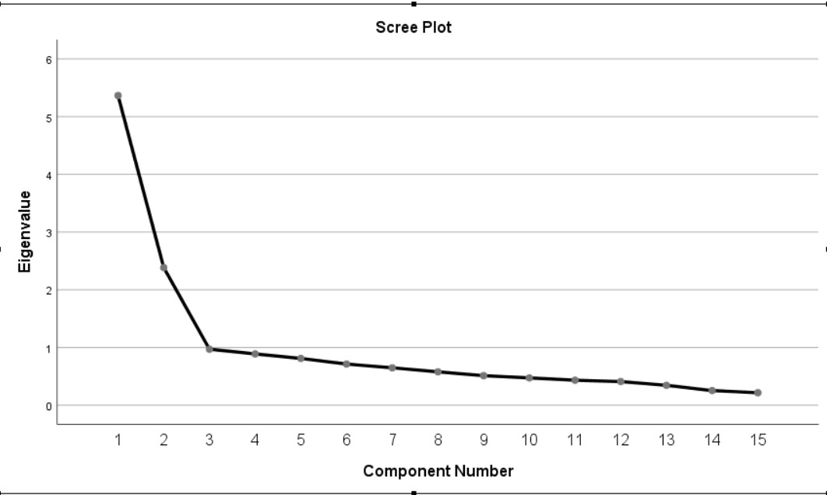
When the eigen value is 1 and the values that are considered to be more than 1 are 2, and when the breaks in the Scree-Plot graph are examined, it is seen that the scale is collected under two dimensions and 15 items.
Table 3. EFA results
Factor Load
Item NO 1. Factor 2. Factor
I1 .724
2 .782
3 .848
4 .741
5 .651
6 .597
10 .751
11 .633
12 .596
15 .569
16 .430
14 .688
19 .561
20 .650
24 .617

After the reliability and suitability determinations, EFA was applied to the items and it was determined that the scale consisted of 5 sub-dimensions in the first place. This was also examined by considering the fractures in the Scree-Plot and it was determined that the breaks in this graph confirmed the five sub-dimensional structures. However, rotation was applied considering that the difference between each item was at least .10 so that the items under different factors were not overlapped. This process was repeated several times, and after proceeding step by step, the scale was given its final shape. As a result of the rotations, the five-dimensional scale consisting of 25 items in the first stage has become a two-dimensional scale consisting of 15 items with the rotations applied. The items on the scale and the factor load of each item were determined. Of these articles, items 1, 1.2, 3, 4, 5, 6, 10, 11, 12, 15 and 16 are sociological sub-dimension; Articles 14, 19, 20, 24 are named as political sub-dimensions.
Table 4. EFA results total explained variance
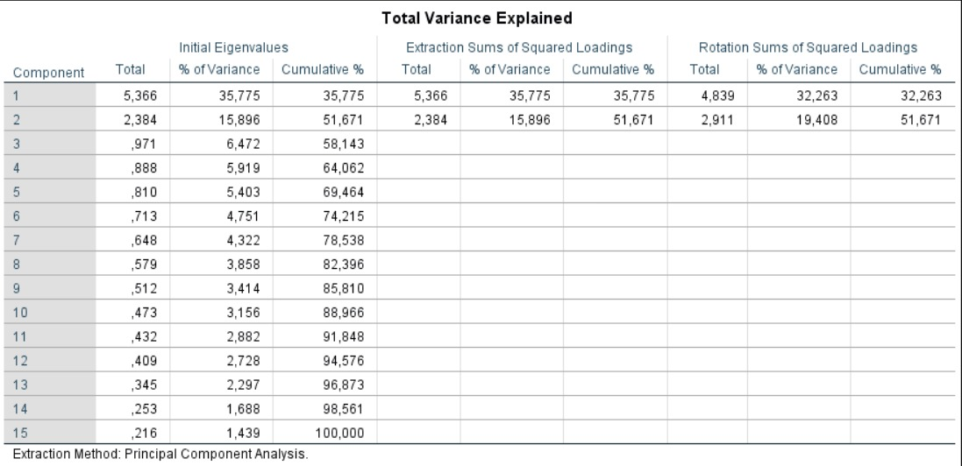
In Table 4, a two-dimensional structure comes to the fore. These dimensions seem to explain a total of close to 51.671% variance of the scale. In the field literature, it is stated that a scale must explain a minimum of 50% of the total variance (Field, 2006). It is seen that the first dimension explains 35.775% of the total variance and the second dimension explains 15.896% of the total variance. As stated in the field literature, each dimension needs to be explained at least 5% of the total variance (Hair et al., 2010). In this respect, it shows that the variance explained by each dimension in the TPS is of the desired sufficiency.
3.2. Findings for confirmatory factor analysis
15 items and two-dimensional scales formed as a result of EFA were applied to 174 people and subjected to CFA in the Analysis of Moment Structures (AMOS) program. The Path Diagram resulting from CFA is given in figure 2.
Figure 2. CFA results
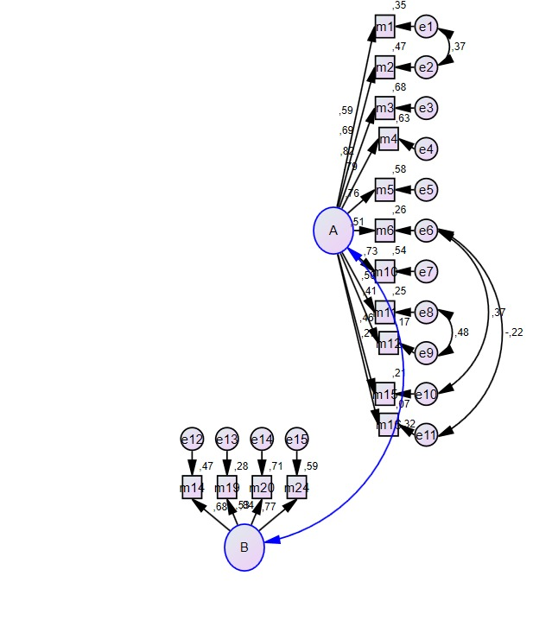
According to the results of EFA, it is seen that the first sub-dimension consists of 11 items, the second sub-dimension consists of four items, and a scale consisting of two sub-dimensions and 15 items in total emerges. Therefore, the scale consisting of two sub-dimensions and 15 items established in EFA was confirmed in CFA.
Model Fit indices were used in the CFA process. X²/sd, AGFI, TLI, RMSEA, GFI, NFI and CFI model fit indices were also used in the study. McMillan and Schumacher (2006) stated that all or some of the model fit indices could be utilized in the CFA. It is also stated that there is no complete consensus in this sense (İlhan et al., 2014, 30-31). Likewise, modification has been proposed among some substances in the CFA. Accordingly, modifications were made between e8 and e9, e6 and e10, e6 and e11, and e1 and e2. These modifications have been identified as contributing to X² (Chi-Square). As seen in Figure 2, it is seen that the Chi-Square fit indices of this scale, which consists of two sub-dimensions and 15 items, are significant (X²/sd=1.664). The values of the fit indices were determined as AGFI=.886, GFI=.905, NFI=.873, TLI=.931, CFI=.944 and RMSEA= .062, respectively. In the field literature, it is stated that there is perfect harmony for the RMSEA value as it approaches 0, values below 0.05 are good harmony, values below 0.08 are reasonable values, and values between 0.08 and 0.10 show a moderate level of harmony, while values above 0.10 are not acceptable (Kline et al., 1989). Therefore, it is seen that the good fit (model fit) values resulting from CFA are acceptable values (Hooper, et al., 2008) in the range of values specified in the field literature.
The final version of the 15 items and two sub-dimensional scales validated in the CFA is calculated and shown in Table 5 by calculating the Cronbach Alpha values to determine the reliability of both the entire scale and each sub-dimension.
Table 5. Cronbach alpha values of the final state and dimensions of the TPS
Factors Cronbach Alpha Values
Sociological Perception 1. Dimension - 11 Items .88
Political Perception 2. Dimention - 4 Items .76
Total 15 Items .85
As can be seen in Table 5, Cronbach's Alpha values for the entire final version of the scale and its two sub-dimensions range from .88 for the sociological perception sub-dimension and .76 for the political perception sub-dimension. In addition, the Cronbach Alpha internal reliability coefficient was found as .85 for the whole scale, which indicates that the final application of the scale is highly reliable. In addition, two semi-reliability analyzes were applied to the final version of the scale consisting of 15 items and the results were shown in Table 6.

Table 6. Two-half confidence analysis
Two Half Cronbach Alpha Values

- Part .87
- Part .82
As stated in Table 6, according to the results of two semi-reliability analyzes of the scale, it was found that the 1st part (r=.87) and the 2nd part (r= .82). Therefore, these values show that TPS is a reliable scale (Büyüköztürk, 2020, p. 182).

Table 7. Values for TPS
Dimension Dimension Name Items

First Dimension Sociological Perception 1,2, 3, 4, 5, 6, 10, 11, 12, 15, 16
Second Dimension Political Perception 14, 19, 20 and 24

When Table 7 is examined, it is seen that the scale consists of two sub-dimensions and 1,2, 3, 4, 5, 6, 10, 11, 12, 15, 16 items are collected under the first sub-dimension and 14, 19, 20 and 24 items are collected under the second dimension. These items are prepared as 5-point likerts as "Strongly disagree" (1) and "Strongly agree" (5).
4. RESULT
Upon reviewing the existing literature, it becomes evident that the notion of tribe is a subject of interest within the realm of qualitative research. This study unveiled the potential for investigating the political and sociological dimensions of the tribe through the utilization of both qualitative and quantitative methodologies. In the context of this research, a questionnaire was administered to a sample of university students in order to develop a measurement tool called the TPS. The TPS consists of 15 items and is organized into two sub-dimensions. Hence, the utilization of this scale has facilitated the identification of the quantitative dimension within a qualitative study, thereby generating a novel scholarly contribution. According to Karakoç and Dönmez (2014, p. 45), it has been asserted that a scale's validity should be equal to or greater than 0.70. The study demonstrated high levels of validity, with a coefficient of .88 for the sociological perception sub-dimension, .76 for the political perception sub-dimension, and .85 for the overall scale. In this regard, it can be argued that the entirety and subordinate aspects of the TPS form a reliable measurement tool. Similarly, two semi-reliability analyses were conducted in order to assess the reliability of a measurement scale. According to Büyüköztürk (2007), the Cronbach Alpha semi-reliability index for the first part of the study was determined to be .87, while the second part yielded a value of .82. Based on these findings, it was concluded that the TPS demonstrated satisfactory levels of reliability.
A total of 231 participants, who possessed nearly ten times the number of items used in the study, were subjected to EFA. Based on the data collected, a total of 15 items were identified, which can be further categorized into two sub-dimensions. Following the completion of the EFA, the questionnaire underwent a subsequent administration to gather a significantly larger amount of new data compared to the remaining items. Additionally, the scale's validity was assessed by subjecting 174 incoming data to CFA. In accordance with the criteria outlined in existing scholarly literature, a scale characterized by strong validity and reliability has been constructed by adhering to the prescribed stages involved in survey development.
Consequently, a measurement instrument characterized by strong validity and reliability has been devised to assess the tribal perceptions held by university students. The utilization of this scale is believed to make a valuable contribution to the academic domain. In this regard, the use of TPS can serve as a suitable metric in research conducted within various domains such as social, political, demographic, and cultural studies.

REFERENCES
Abdulla, N. (2009). İmparatorluk sınır ve aşiret: kürdistan ve 1843-1932 türk-fars sınır çatışması. Avesta Yayınları.
Akın, A. & Akın, Ü. (2015). Allah algısı ölçeği türkçe formunun geçerlik ve güvenirliği. BJSS Balkan Journal of Social Sciences / Balkan Sosyal Bilimler Dergisi, 4(7).
Aladağ, C.(1981). Milli mesele ve kürdistanda feodal aşiret. Komkar Matbaası.
Avcıoğlu, D. (1976). Türkiye'nin düzeni:dün -bugün –yarın. Tekin Yayınevi (10. baskı).
Bardakçı, S. (2010), The validity and reliability study of the scale of the perceived sociability of online learning environments. Ankara University, Journal of Faculty of Educational Sciences, 43(1), 17-39.
Beşikçi, İ. (1969). Doğu anadolu düzeni: sosyo-ekonomik ve etnik temeller. e-Yayınları.
Beyoğlu, A. (2015). Sanat eğitiminde algı, görsel algı ve yanılsama: Victor Vasarely’nin çalışmaları üzerine bir inceleme. Trakya Üniversitesi Sosyal Bilimler Dergisi, 17(1), 333-348.
Bilgin, M. S. (1990). Barzani. Fırat Yayınları.
Browne, M. W. & Cudeck, R. (1989). Single sample crossvalidation indexes for covariance-structures. Multivar Behav Res, 24(4), 445-55.
Bruinessen, V. M. (2013). Ağa şeyh devlet (Çev. B. Yalkut). İletişim Yayınları (8. baskı).
Büyüköztürk, Ş. (2007). Sosyal bilimler için veri analizi el kitabı. Pegem Yayıncılık (8. baskı).
Büyüköztürk, Ş. (2020). Sosyal bilimler için veri analizi el kitabı. Pegem Akademi Yayıncılık (27. baskı).
Creswell, J. W.(2013). Research design: Qualitative, quantitative, and mixed methods approaches. 2nd edition, Thousand Oaks, CA: Sage Publications.
Çokluk, Ö. & Şekercioğlu, G. & Büyüköztürk, Ş. (2012). Sosyal bilimler için çok değişkenli istatistik: spss ve lisrel uygulamalari. Pegem Akademi.
Erol, E. (2015). Perceptions of organizational politics scale (POPS) questionnaire into Turkish: A validity and reliability study, Internationaş Journal of Assesment Tool in Educations, 2(1), 58-78.
Field, A. (2006). Research methods ii: reliability analysis. Sage Publications.
Giray, M. D. & Şahin, D. N. (2012). Algılanan örgütsel, yönetici ve çalişma arkadaşlari desteği ölçekleri: geçerlik ve güvenirlik çalişmasi. Türk Psikoloji Yazıları, 15(30), 1-9.
Gökalp, Z. (2011). Kürt aşiretleri hakkinda sosyolojik tetkikler. Kaynak Yayınları (3. baskı).
Gökulu, G. (2020). Sosyal bilimler alaninda öğrenim gören üniversite öğrencilerinin eğitim memnuniyeti ölçeğinin geliştirilmesi. Uluslararası Toplum Araştırmaları Dergisi,15(23), 1790-1807.
Hair, J. & Black, C. & William, B. & Barri J. & Anderson, R. (2020). Multivariate data analysis. 7th edition, Prentice-Hall.
Hooper, D. & Coughlan, J. & Mullen, M. (2008) Structural equation modelling: guidelines for determining model fit. Electronic Journal of Business Research Methods, 6(1), 53-60.
İlhan, M. & Çetin, B. (2014). LISREL ve AMOS programlari kullanilarak gerçekleştirilen yapisal eşitlik modeli (YEM) analizlerine ilişkin sonuçlarin karşilaştirilmasi. Eğitimde ve Psikolojide Ölçme ve Değerlendirme Dergisi, 5(2), 26-42.
Kacmar, K. M. & Ferris, G. R. (1991). Perceptions of organizational politics scale (POPS): Development and construct validation. Educational and Psychological Measurement, 51(1), 193-205.
Karadeniz, S. (2012). Aşiret sisteminde dönüşüm, aşiretin kentte aldiği yeni şekiller: Batman örneği. (YÖK Tez Merkezi, Doktora Tezi). İnönü Üniversitesi.
Karakoç Alatlı, B. (2012). Başarinin değerlendirilmesinde algilanan halo etkisi ölçeğinin geliştirilmesi. (YÖK Tez Merkezi, Yüksek Lisans). Ankara Üniversitesi.
Karakoç, F. Y. & Dönmez, L. (2014). Ölçek geliştirme çalişmalarinda temel ilkeler. Tıp Eğitimi Dünyası, 13(40), 39-49.
Kline, R. B. (2011). Hypothesis testing. principles and practice of structural equation modeling. 3rd ed., The Guilford Press.
Korkmaz, E. (2018). Hakkari’de aşiret ve siyaset ilişkisi (1880-2011). Sitav Yayınları.
Kul, S. (2014). Uygun istatistiksel test seçim klavuzu. Plevra Bülteni, 8(2), 26-29.
Mcmillan, J. H. & Schumacher, S. (2006). Research in education. A conceptual in-troduction. 5th ed.. Addison Wesley Longman Inc.
Ökten, A. (2020). David Hume’da algi ve dış dünya problemi. Sonçağ Akademi Yayınları.
Pallant, J. (2017). SPSS kullanma kilavuzu SPSS ile adim adim veri analizi (Çev. S. Balcı). Anı Yayınları.
Saydam, A. (2009). Sultanın özel statüye sahip tebaasi: konar göçerler. SDÜ Fen Edebiyat Fakültesi Sosyal Bilimler Dergisi, 2009(20), 9-31.
Seçer, İ. (2015). Psikolojik test geliştirme ve uyarlama süreci: SPSS ve LISREL uygulamaları. Anı Yayıncılık.
Tabachnick, B. G. & Fidel, L. S. (2007). Using multivariate statistics. Allyn and Bacon.
Taşdan, M. (2013). İlköğretim okullarinda örgütsel kimlik algisi ölçeğinin geliştirilmesi. Ankara University, Journal of Faculty of Educational Sciences, 46(2), 1-24.
Todorov, T. (2003). Hope and memory: Reflections on the twentieth century. Atlantic Books.
Uluç, V. (2010). Kürtlerde sosyal ve siyasal örgütlenme: Aşiret. Mukaddime Dergisi, 2(2), 35-52.

Appendices
Annex-1.
TPS Sub-Dimensions and Five-Likert
Item No | Sociological Perception Sub-Dimension | Strongly Disagree | Disagree | Undecided | Agree | Stgrongly Agree
1 | I am a tribal member.
2 | Tribal membership is very important to me.
3 | Being a member of a tribe improves my sense of cohesion, cooperation and security.
4 | I prefer to live in the same neighborhood or neighborhoods as members of my tribe.
5 | I participate in my tribe's social activities (weddings, condolences, holidays, etc.).
6 | There is equality between men and women within the tribal structure.
7 | Tribe has a positive effect on solving a social problem.
8 | Tribal leadership has a counterpart in the eyes of the local people.
9 | I think that the tribe has an impact on the daily life practice of its members.
10 | Within the tribal structure, there is individual freedom in making political choices.
11 | If any member of my tribe is a candidate for a political party, my voting preference changes in favor of that party.
 | Political Perception Sub-Dimension | Strongly Disagree | Disagree | Undecided | Agree | Stgrongly Agree
12 | The tribal system is seen as a vote depot by political parties.
13 | Today, within the tribal structure, I think that different tribes are united in the same party.
14 | I think the tribes have an effect on the local political parties.
15 | The tribal structure is effective in the distribution of the votes of the parties.

The questions were asked to the participants in Turkish.

